NAAN MUDHALVAN

NAME:S.PRATHIPARAJ

COURSE:SALESFORCE

NM ID: 5C345BD9CA9CFCEA2CF42960F8C60D2C

Task1:

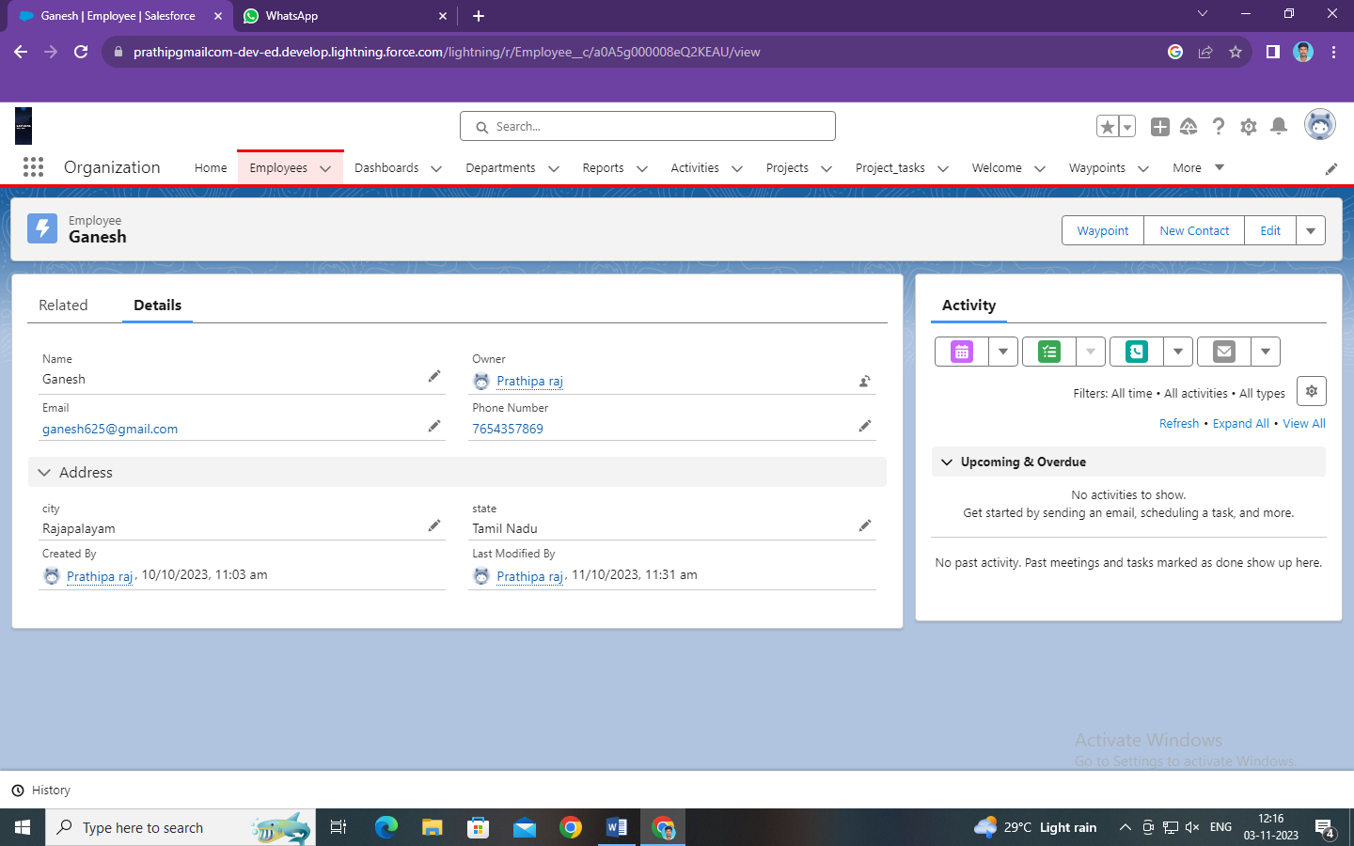

Task 2:

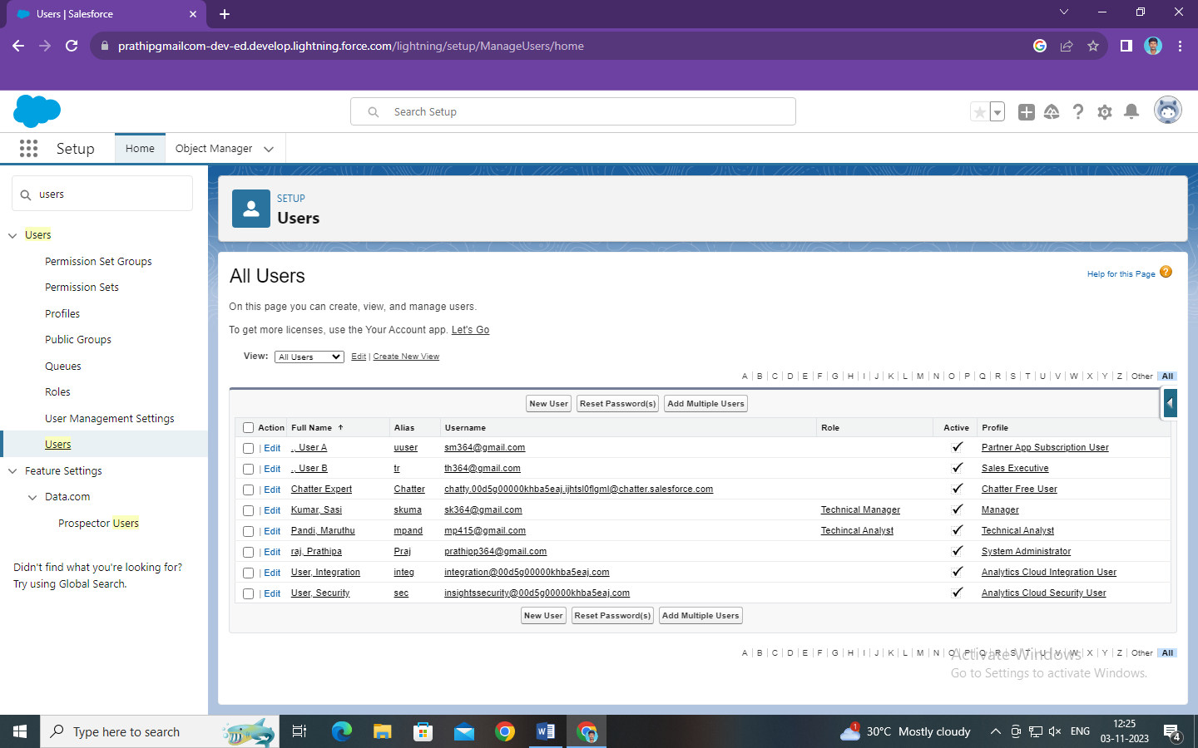

Task 3:

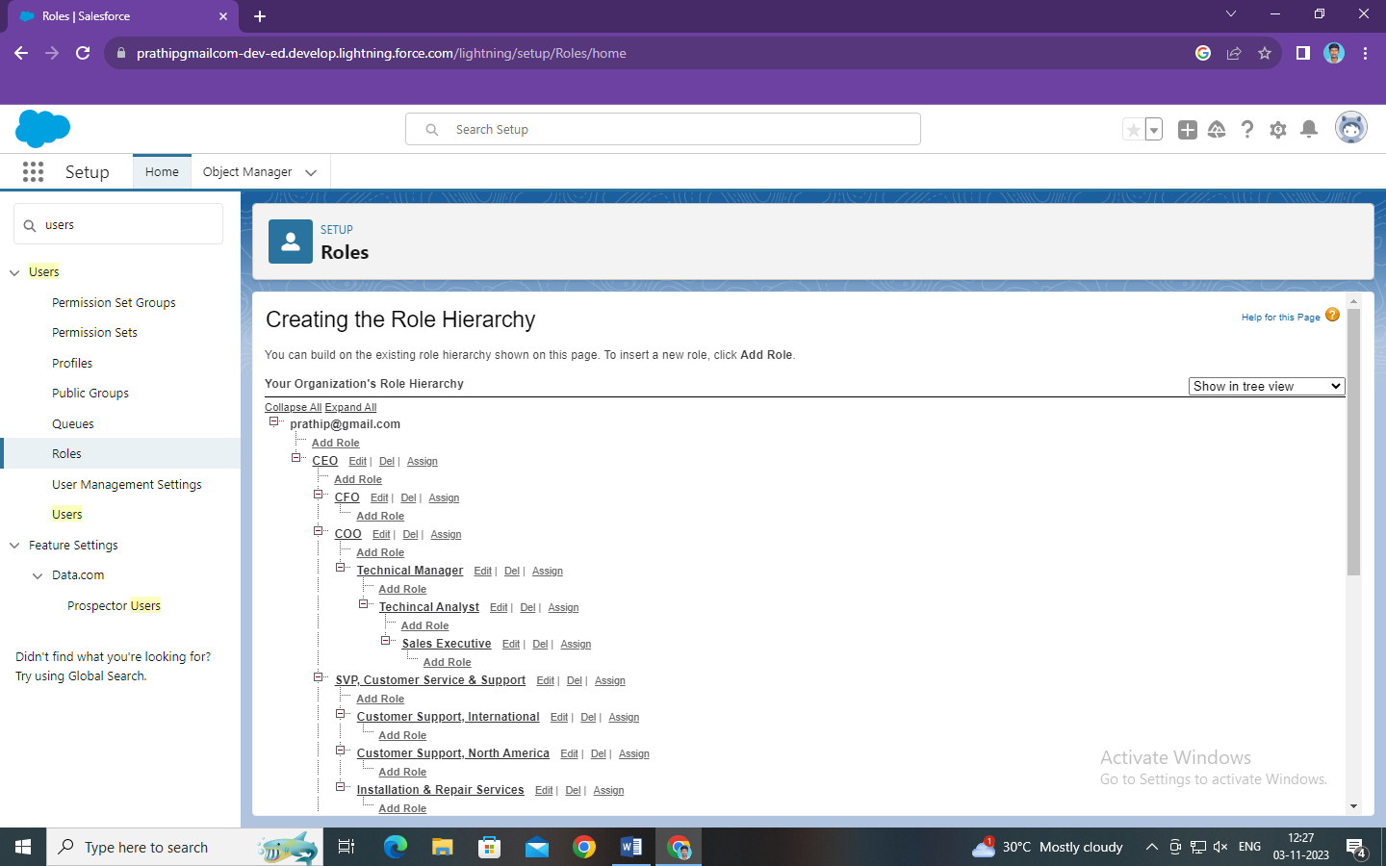

Task 4:

